A GEOLOGICAL FRAMEWORK FOR THE NORTHERN MOLONG VOLCANIC BELT, EASTERN LACHLAN OROGEN: IMPLICATIONS FOR REGIONAL CORRELATIONS AND ALKALIC PORPHYRY GOLD-COPPER METALLOGENESIS

Peter Duerden
Alkane Resources Ltd, 19 Kenna Street, Orange, NSW, 2800

Key Words: Macquarie Arc, Molong Volcanic Belt, Kaiser Project, Bodangora Formation, Kaiser Volcanics

Abstract
The northern extent of the Molong Volcanic Belt (MVB), within the eastern Lachlan Orogen, is considered highly prospective for alkalic porphyry gold-copper mineralisation (e.g. Cadia porphyry district).
The area remains poorly understood compared with the southern and central portions of the belt and is described as a sequence of basalt, basaltic andesite, latite lavas, intrusions, volcaniclastic breccia, conglomerate, sandstone, siltstone and allochthonous limestone (Late Ordovician Oakdale Formation).
Alkane’s exploration activity at the Kaiser (EL6209), Bodangora (EL4022) and Finns Crossing (EL8261) projects has established a geological framework and facies architecture for the region which highlights strong similarities with the world class Cadia porphyry district.
Restoration of structural patterns reveals a basal package of fine grained volcaniclastic rocks and basaltic lavas (informally termed the Bodangora Formation). These deep water facies grade upwards through a transitional carbonate interval into a sequence of andesitic lavas and coarse volcaniclastics (informally termed the Kaiser Volcanics). This switch from distal turbiditic to proximal volcanic-derived sedimentation is also well documented in the Cadia stratigraphy, where a basement of feldspathic turbidites and basaltic lavas (Weemalla Formation) is overlain by a transitional carbonate sequence and andesitic lavas and coarse volcaniclastics (Forest Reefs Volcanics).
The proposed stratigraphic correlations are also supported by a similar chemostratigraphy in both areas, defined by a temporal change from high-K calc-alkaline to shoshonitic magmatism.
The exploration implications of the geological framework and correlations with the Cadia district are demonstrated by recent targeting success at the Kaiser Project (EL6209).
A new geological framework for the Kaiser area interprets an area of known porphyry mineralisation (Kaiser Mine) as a small element of a larger, structurally dismembered alkalic porphyry system outside the western margin of the Kaiser Intrusive Complex. The framework predicts the continuation of the Kaiser Mine porphyry system via the interplay of west-northwest dextral and north trending sinistral faults (D₂) into the Duke Prospect area and is validated by strongly encouraging recent drilling results (78m @ 0.45% Cu, 0.30g/t Au from 115m, inc. 16m @ 0.87% Cu, 0.57g/t Au from 126m, KSRC010).
Comparisons with the Cadia porphyry district indicates the combined Kaiser-Duke alkalic porphyry Au-Cu system is located at the equivalent setting (outside the main intrusive complex) and stratigraphic contact (Weemalla Fm – Forest Reefs Volcanics equivalent) to the high grade Ridgeway Deposit in the Cadia district and is considered a compelling exploration target.

Introduction
The northern extent of the Molong Volcanic Belt (MVB), within the eastern Lachlan Orogen, is considered highly prospective for alkalic porphyry gold-copper mineralisation (e.g. Cadia porphyry district; >52Moz Au; Newcrest, 2015).
The area remains poorly understood compared with the southern and central portions of the belt which have received much of the regions research attention and were included in the major government and industry funded ‘NSW Ordovician’ SPIRT mapping project in the late 1990s.
Alkane’s exploration activity at the Kaiser (EL6209), Bodangora (EL4022) and Finns Crossing (EL8261) projects has established a geological framework which highlights strong similarities with the Cadia district and has significant implications for alkalic porphyry exploration throughout the Macquarie Arc.
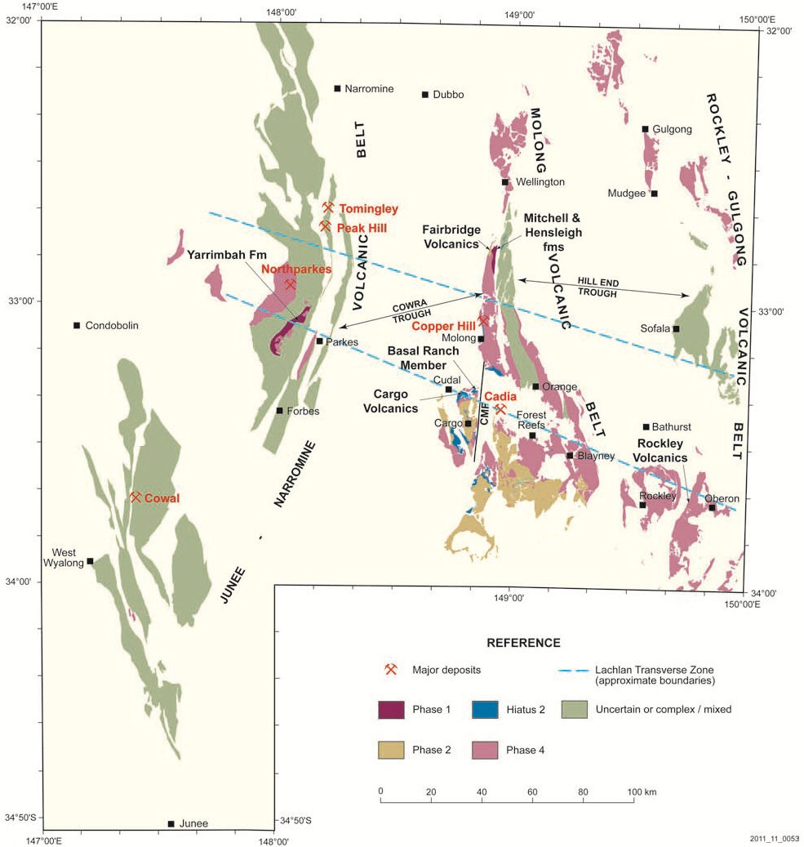
NTZ
LTZ
HRTZ

Figure 1 Location of main belts of Ordovician volcanics and volcaniclastics (Macquarie Arc). Modified from Percival and Glen (2007). The Lachlan Transverse Zone (LTZ) from Glen and Walshe (1999). Nyngan Transverse Zone (NTZ) from Hilyard et al. (1996). Hunter River Transverse Zone (HRTZ) from Glen and Beckett (1997)

A geological framework for the northern Molong Volcanic Belt
The volcanosedimentary sequence of the northern MVB was previously mapped as extensive areas of Oakdale Formation within the Ordovician Cabonne Group (Morgan et al., 1999).
The Oakdale Formation is one of the most widespread units in the Cabonne Group, comprising basalt, basaltic andesite, latite lavas and intrusions, volcaniclastic breccia, conglomerate, sandstone, siltstone and allochthonous limestone (Morgan et al., 1999).
The restoration of folding and fault patterns reveals the original facies and stratigraphic relationships and defines a basal package of fine grained volcaniclastic rocks and basaltic volcanics (informally termed the Bodangora Formation). These deep water facies grade upwards through a transitional carbonate – basaltic volcanics interval into a sequence of andesitic lavas and coarse volcaniclastics (informally termed the Kaiser Volcanics) (Figure 2).
Structural patterns are dominated by north-northwest trending meridional attenuated fold limbs and thrust faults (D₁, σ₁~260-080º) with a later stage of deformation evident by crosscutting northeast-southwest trending thrusts, folds and an oblique system of wrench faults (D_{2,} σ₁~300-110º).
The late stage wrench faults are of critical importance to exploration and include sets of west northwest and northeast trending dextral faults and sinistral reactivation of pre-existing (F₁) north-northwest trending faults. The interplay between these D₂ fault systems has resulted in structural repetitions of several porphyry systems in the northern MVB (see Exploration implications).

Regional correlations
The differences due to the higher degree of strain in the northern MVB is important to recognise; however following the restoration of structural patterns, the original facies architecture becomes apparent and highlights strong similarities with the Cadia district.
The oldest rocks at Cadia are represented by feldspathic turbidites and interlayered basaltic volcanics of the Weemalla Formation (Pogson and Watkins 1998). Similarly the recently defined basal package in the northern MVB is represented by fine grained volcaniclastics and interlayered basaltic volcanics of the informally named Bodangora Formation. A switch from distal turbiditic to proximal, volcanic-derived sedimentation is evident in both areas, with overlying andesitic lavas and coarse volcaniclastics of the Forest Reefs Volcanics in the Cadia district (Harris et al., 2014) and the informally named Kaiser Volcanics in the northern MVB.
The proposed regional correlations are consistent with the recent redefinition of the stratigraphic position of the Mt Pleasant Basalt Member (MPBM) in the Cadia district. The MPBM is now mapped within a transitional sequence of mixed carbonate (Gisbornian) and basaltic volcanics towards the top of the Weemalla Formation (previously within the Forest Reefs Volcanics; Harris et al., 2014). This revised stratigraphic position supports a correlation with basaltic volcanics within the transitional unit towards the top of the Bodangora Formation in the northern MVB (Figure 2). This correlation is also supported by the fact that both units (MPBM, Bodangora Basalt Member) represent the first manifestation of shoshonitic volcanism in the volcanosedimentary sequences (Figure 3).

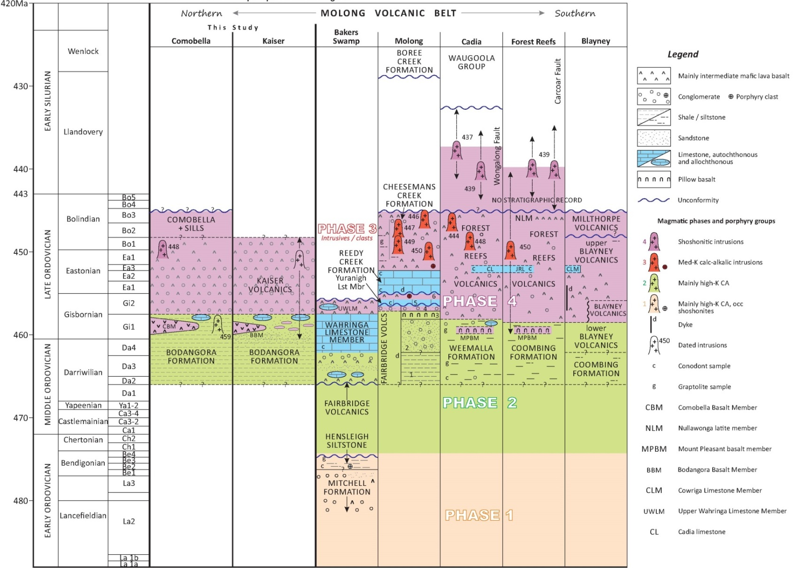

Figure 2 Time-space plot of the Molong Volcanic Belt (north to south), incorporating portions of the Macquarie Arc time space plots from Glen et al., (2012), Note the recent re-positioning of the Mt Pleasant Basalt Member into the upper Weemalla Formation (from the lower Forest Reefs Volcanics) and addition of Gisbornian carbonate bodies according to Harris et al., (2014). Magmatic phases interpretation from Crawford et al., (2007) and Glen et al., (2007)
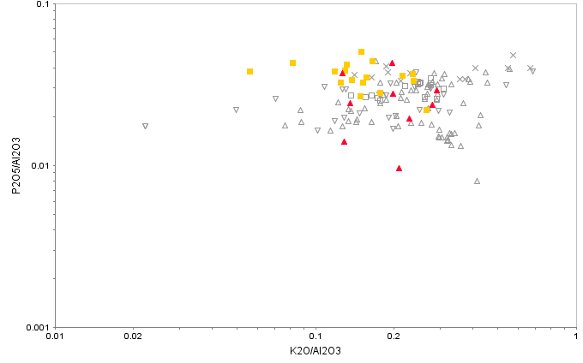  Upper Blayney Volcanics (southern MVB)  Millthorpe Volcanics (southern MVB)  Forest Reefs Volcanics (southern MVB)  a)  Shosh  High K  Low K  Med K  Mount Pleasant Basalt Member (southern MVB)  Bodangora Basalt Member (informal name, northern MVB)  Kaiser Volcanics (informal name, northern MVB) | 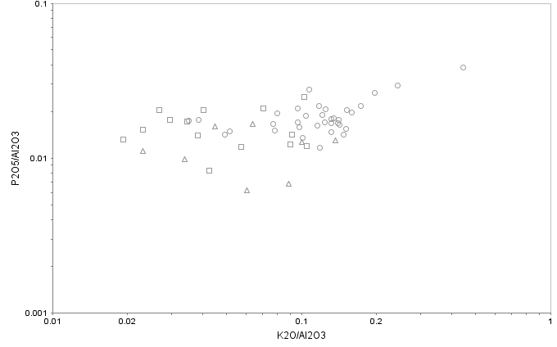  b)  Low K  Med K  High K  Shosh  Fairbridge Volcanics – eastern basal (central MVB)  Fairbridge Volcanics – southern basal (central MVB)  Blayney Volcanics – Lower (southern MVB)
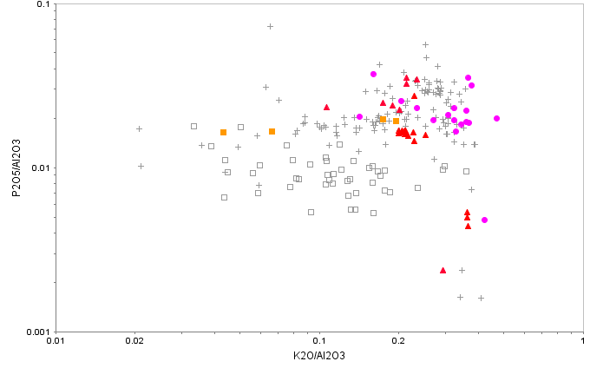

Figure 3

K₂O/Al₂O₃ vs P₂O₅/Al₂O₃ plots of Molong Volcanic Belt volcano-plutonic units indicating magmatic affinities. Fields and regional data taken from Crawford et al., (2007). (a) Phase 4 volcanic suites, including Forest Reefs Volcanics, Millthorpe Volcanics, Upper Blayney Volcanics, Mt Pleasant Basalt Member combined with new data from the northern MVB, including Bodangora Basalt Member (Bodangora Formation), Kaiser Volcanics (informal names). (b) High- K calc-alkaline magmatic suites (Phase 2), including Lower Fairbridge Volcanics, Lower Blayney Volcanics. (c) Intrusive suites, including Cadia Intrusive Complex, Copper Hill Intrusive Suite combined with new data from the northern MVB, including Kaiser Intrusive Complex, Comobella Intrusive Complex, Finns Crossing Intrusive Complex
c)
Shosh
High K
Med K
Low K
Comobella Intrusive Complex (informal name, northern MVB)
Finns Crossing Intrusive Complex (informal name, northern MVB)
Kaiser Intrusive Complex (informal name, northern MVB)
Copper Hill Intrusive Suite (central MVB)
Cadia Intrusive Complex (southern MVB)

Exploration implications
The geological framework has enabled the identification and ranking of alkalic porphyry targets in the northern MVB. The improved geological understanding has been integrated with features of the Cadia alkalic Au-Cu porphyry systems to develop exploration criteria, including:
- Target areas along the arc which show a similar facies architecture to the Cadia district, i.e. restricted volcanosedimentary basins
- Target the outboard margins of major alkalic intrusive complexes, i.e. higher grade ‘intrusion-centred’ porphyries; e.g. Ridgeway, Cadia East Deposits outside the Cadia Intrusive Complex
- Target the Bodangora Formation - Kaiser Volcanics contact, i.e. correlate of the Weemalla Formation – Forest Reefs Volcanics contact which is an important control on high-grade porphyry mineralisation at the Ridgeway Deposit, Cadia district
- Target hydrothermal alteration vectors based on the zonation and overprinting relationships at other Macquarie Arc alkalic porphyry systems (e.g. Holliday and Cooke 2007)
- Target structural repetitions of known porphyry systems, i.e. late-stage brittle displacements by wrench fault systems
The exploration implications of the geological framework and correlations with the Cadia district are demonstrated by recent targeting success at the Kaiser Project (EL6209).

Kaiser Project
The Kaiser Project (EL6209) has been subject to intensive exploration since the 1960’s (>15 km of historical drilling), with much of the activity focused on resource drilling at the Kaiser Mine Prospect (0.4Mt @ 1% Cu, 1g/t Au Inferred Resource; Pratt, 2008) or within the Kaiser Intrusive Complex (KIC).
Recent exploration activity has focussed on the underexplored outboard margins of the KIC, a position analogous to the setting of high-grade porphyry deposits outside the Cadia Intrusive Complex in the Cadia district (‘intrusion-centred’ porphyries; e.g. Ridgeway, Cadia East). The prospectivity of this marginal intrusive complex setting is emphasized by the occurrence of high-grade alkalic porphyry Au-Cu mineralisation at the Kaiser Mine Prospect which provides evidence that critical brine-forming hydrothermal processes operated outside the main KIC.
A new geological framework for the Kaiser area interprets an area of known porphyry mineralisation (Kaiser Mine) as a small element of a larger, structurally dismembered alkalic porphyry system outside the western margin of the Kaiser Intrusive Complex. The framework predicts the continuation of the Kaiser Mine porphyry system via the interplay of west-northwest dextral and north trending sinistral faults (D₂) into the Duke Prospect area and is validated by strongly encouraging recent drilling results (78m @ 0.45% Cu, 0.30g/t Au from 115m, inc. 16m @ 0.87% Cu, 0.57g/t Au from 126m, KSRC010; Alkane, 2015) (Figure 4).
Comparisons with the Cadia porphyry district indicates the combined Kaiser-Duke alkalic porphyry Au-Cu system is located at the equivalent setting (outside the main intrusive complex) and stratigraphic contact (Weemalla Fm – Forest Reefs Volcanics equivalent) to the high grade Ridgeway Deposit in the Cadia district and is considered a compelling exploration target (Ridgeway total resource: 157Mt @ 0.8g/t Au, 0.39% Cu; Newcrest, 2008).
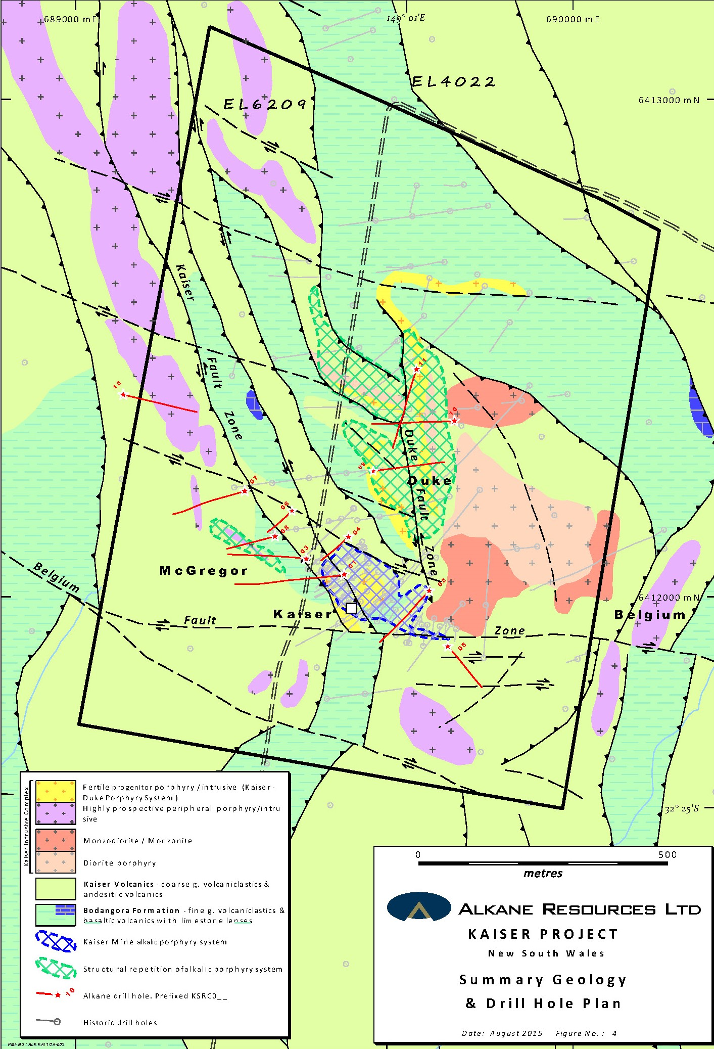
Figure 4 Summary geology and drilling plan, showing the structurally dislocated Kaiser-Duke alkalic porphyry Au-Cu system at the western margin of the Kaiser Intrusive Complex. The steep westerly dip of the porphyry-intrusive complex suggests very few historical holes have intersected the target zone. Recent RC drilling results in Table
KAISER PROJECT RC DRILLING – 2014-2015 (>0.1% Cu)
Hole ID | Easting (MGA) | Northing (MGA) | Dip | Azimuth (Magnetic) | Total Depth (m) | Interval From (m) | Interval To (m) | Intercept (m) | Au (g/t) | Cu (%) | Prospect
KSRC001 | 689543 | 6412039 | ‐50 | 248 | 322 | 0 | 60 | 60 | 0.81 | 0.91 | Kaiser Mine
 |  |  |  |  | inc. | 18 | 59 | 41 | 1.15 | 1.24
 |  |  |  |  | inc. | 37 | 59 | 22 | 1.63 | 1.64
KSRC002 | 689708 | 6412009 | ‐50 | 212 | 223 | 3 | 29 | 26 | 0.11 | 0.17 | Kaiser East
 |  |  |  |  | and | 34 | 54 | 20 | 0.15 | 0.16
 |  |  |  |  | and | 68 | 86 | 18 | 0.50 | 0.15
 |  |  |  |  | inc | 68 | 75 | 7 | 0.73 | 0.26
 |  |  |  |  | and | 136 | 140 | 4 | 0.19 | 0.27
 |  |  |  |  | and | 143 | 152 | 9 | 0.14 | 0.23
KSRC003 | 689462 | 6412078 | ‐50 | 267 | 241 | 109 | 141 | 32 | 0.13 | 0.39 | McGregor
 |  |  |  |  | inc | 110 | 115 | 5 | 0.51 | 1.42
 |  |  |  |  | and | 132 | 141 | 9 | 0.13 | 0.32
 |  |  |  |  | and | 171 | 172 | 1 | 9.69 | ‐
KSRC004 | 689547 | 6412119 | ‐50 | 217 | 121 | NO SIGNIFICANT RESULTS |  |  |  |  | Kaiser Mine
KSRC005 | 689745 | 6411899 | ‐50 | 125 | 187 | NO SIGNIFICANT RESULTS |  |  |  |  | Kaiser Extended
KSRC006 | 689435 | 6412173 | -65 | 215 | 159 | ABANDONED – NOT ASSAYED |  |  |  |  | McGregor
KSRC007 | 689340 | 6412213 | -50 | 241 | 228 | ABANDONED – NO SIGNIFICANT RESULTS |  |  |  |  | McGregor
KSRC008 | 689401 | 6412122 | -60 | 244 | 168 | ABANDONED – NO SIGNIFICANT RESULTS |  |  |  |  | McGregor
KSRC009 | 689598 | 6412252 | -55 | 68 | 319 | 0 | 12 | 12 | 0.82 | 0.20 | Duke Western
 |  |  |  |  | and | 19 | 50 | 31 | 0.18 | 0.16
 |  |  |  |  | and | 57 | 69 | 12 | 0.15 | 0.11
 |  |  |  |  | and | 75 | 117 | 42 | 0.29 | 0.13
 |  |  |  |  | incl. | 91 | 97 | 6 | 0.78 | 0.22
 |  |  |  |  | and | 147 | 285 | 138 | 0.29 | 0.17 | Duke Central
 |  |  |  |  | incl. | 169 | 175 | 6 | 0.97 | 0.35
 |  |  |  |  | and | 304 | 317 | 13 | 0.17 | 0.11
KSRC010 | 689761 | 6412354 | -57 | 255 | 270 | 26 | 58 | 32 | 0.24 | 0.14 | Duke Eastern
 |  |  |  |  | and | 115 | 227 | 112 | 0.24 | 0.36 | Duke Central
 |  |  |  |  | incl. | 126 | 142 | 16 | 0.57 | 0.87
 |  |  |  |  | incl. | 115 | 193 | 78 | 0.30 | 0.45 | Duke Central
 |  |  |  |  | and | 128 | 132 | 4 | 0.78 | 1.45
 |  |  |  |  | and | 139 | 141 | 3 | 1.13 | 1.52
 |  |  |  |  | incl. | 151 | 165 | 14 | 0.58 | 0.63
KSRC011 | 689685 | 6412457 | -56 | 185 | 318 | 12 | 44 | 32 | 0.07 | 0.14 | Duke Central
 |  |  |  |  | and | 55 | 65 | 10 | 0.19 | 0.24
 |  |  |  |  | and | 72 | 126 | 54 | 0.14 | 0.33
 |  |  |  |  | incl. | 73 | 78 | 5 | 0.45 | 1.15
 |  |  |  |  | and | 134 | 213 | 79 | 0.22 | 0.37
 |  |  |  |  | incl. | 198 | 201 | 3 | 0.52 | 0.85
 |  |  |  |  | and | 221 | 230 | 9 | 0.14 | 0.21
KSRC012 | 689096 | 6412406 | -50 | 90 | 210 | NO SIGNIFICANT RESULTS |  |  |  |  | McGregor North
Table 1 Register of Alkane’s RC drilling results (2014-2015)

References
Alkane, 2015, New porphyry gold-copper mineralisation in the Kaiser Project, ASX announcement 21-1-2015, Alkane Resources Ltd.
Crawford, A.J., Meffre, S., Squire, R.J., Barron, L.M., Falloon, T.J., 2007, Middle and Late Ordovician magmatic evolution of the Macquarie Arc, Lachlan Orogen, New South Wales: Australian Journal of Earth Sciences, v. 54, p. 181-214.
Glen, R.A., Crawford, A.J., Percival I.G. and Barron, L.M., 2007, Early Ordovician development of the Macquarie Arc, Lachlan Orogen, New South Wales. Australian Journal of Earth Sciences, v. 54, p. 167-179.
Glen, R.A., Quinn, C.D., Cooke, D.R., 2012, The Macquarie Arc, Lachlan Orogen, New South Wales: its evolution, tectonic setting and mineral deposits: Episodes, v. 35, no. 1, p. 177-186.
Glen, R.A. , and Beckett, J., 1997, Structure and tectonics along the inner edge of a foreland basin: the Hunter Coalfield in the northern Sydney Basin, New South Wales Australian Journal of Earth Sciences v. 44, p 853-877.
Glen, R.A., and Walshe, J.L., 1999, Cross-structures in the Lachlan Orogen; the Lachlan transverse zone example: Australian Journal of Earth Sciences, v. 46, p. 641-658.
Harris, A. C., Percival, I. G., Cooke, D. R., Tosdal, R. M., Fox, N., Allen, C. M., Tedder, I. J., McMillan, C., Dunham, P. D., and Collett, D., 2014, Marine Volcanosedimentary Basins Hosting Porphyry Au-Cu Deposits, Cadia Valley, New South Wales, Australia: Economic Geology, v. 109, p. 1117-1135.
Hilyard, D., Drummond, M., Clare, A., Sanders, Y., Aung, Z., Glen, R. A., Ruszkowski, P., Fleming, G., Lewis, P., and Robson, D., 1996, Preliminary Paleozoic bedrock interpretation of the Narromine and Nyngan 1:250 000 sheet areas: Geological Survey of New South Wales Quarterley Notes, v. 101, p. 1-16.
Holliday, J. R., and Cooke, D. R., 2007, Advances in Geological Models and Exploration Methods for Copper + Gold Porphyry Deposits, in Proceedings Proceedings of Exploration 07: Fifth Decennial International Conference on Mineral Exploration. p. 791-809.
Morgan E.J., Cameron R.G., Colquhoun G.P., Meakin N.S., Raymond O.L., Scott M.M., Watkins J.J., Barron L.M., Henderson G.A.M., Krynen J.P., Pogson D.J., Warren A.Y.E., Wyborn D., Yoo E.K., Glen R.A. & Jagodzinski E.A., 1999. Dubbo 1:250 000 Geological Sheet SI/55-4, (2nd edition). Geological Survey of New South Wales, Sydney and Australian Geological Survey Organisation, Canberra.
Newcrest, 2015. Mineral Resources and ore reserves statement 2015. http:// www.newcrest.com.au /resources-and-reserves/resources-and-reserves-page/resources-and-reserves-statements. Newcrest Mining Ltd.
Percival, I. G., and Glen, R. A., 2007, Ordovician to Earliest Silurian History of the Macquarie Arc, Lachlan Orogen, New South Wales: Australian Journal of Earth Sciences, v. 54. p. 143-165.
Pogson, D.J., and Watkins, J.J., 1998, Bathurst geological sheet 1:250 000, Sydney, Australia, Geological Survey of New South Wales, Dept. of Mineral Resources, 430 p.
Pratt, B.T., 2008. Finalised estimate of the copper and gold resource of the Kaiser Mine near Wellington, NSW, Ajax Joinery Pty Ltd company report.

